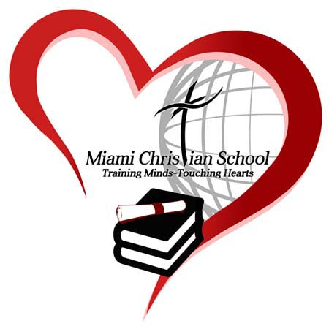**Miami Christian School Volunteer Community Service Documentation Form**

Return form to: Miami Christian School

Registrar 200 NW 109th Ave.

María Méndez Miami, FL 33172

305-221-7754 Ext. #715 www.miamichristian.org

Fax: 305-221-7783

Student’s Name:

Name of Organization/Non-Profit/Event:

Address:

Phone Number:

|  |  |  |
| --- | --- | --- |
| **Date of the Event** | **Brief Description of Service Activity** | **Total Hours Per Day** |
|  |  |  |
|  |  |  |
|  |  |  |
|  |  |  |
|  |  |  |
|  |  |  |

Specific Duties/Services Performed:

Supervisor Name (Please Print)

Supervisor Signature

Address (if different from above)

Date: / / Phone Number:

See the back of this form for requirements/restrictions

**Community Service Hours**

* Community service hours must be submitted on an MCS community service for or a company letterhead **(Volunteering for family is not considered community service, this includes parents, grandparents, aunts, uncles and siblings)**
* If a student volunteers at the same business where their parent is employed the community service document must be signed by an office manager or owner who is not the parent. Community service hours should never be signed by the student’s parent.
* Any submission of more than 50 hours must show documentation of the hours worked (a time card or log sheet form)
* Travel time is included to local events such as Special Olympics.

**Community service hours are earned through volunteering for the following:**

***Organization*** – Churches, Schools, Hospitals, Politician’s Office, Doctor’s Office etc.

***Individuals*** – Neighbors, elderly, babysitting, etc. As noted above a student may not work for their family or family-owned business.

***Mission trips***- students are given credit for 8 hours per day, including travel days. If the group does **not** work for a day that day is not included in the time.

Miami Christian School does not require a minimum of Service Hours for graduation. However, the school strongly encourages each student to do community service by rewarding students K3 – 12th grade with awards at the end of the school year. Community service has a positive influence on the universities and scholarships opportunities. To qualify for the Florida Bright Futures FAS Scholarship a student must have completed 100 hours of service.

Rev. 12/ 18/23