**Videos related to your Algebra 2 - Summer Packet:**

***Adding and subtracting fractions***: https://www.youtube.com/watch?v=N-Y0Kvcnw8g

***Multiplying fractions:*** Do not forget to **simplify** before to multiply. https://www.youtube.com/watch?v=UacpcSkBhbM

***Dividing fractions:*** Apply the Keep Change Flip (KCF) rule. Then you can simplify https://www.youtube.com/watch?v=4lkq3DgvmJo

***Operations with integer numbers:***

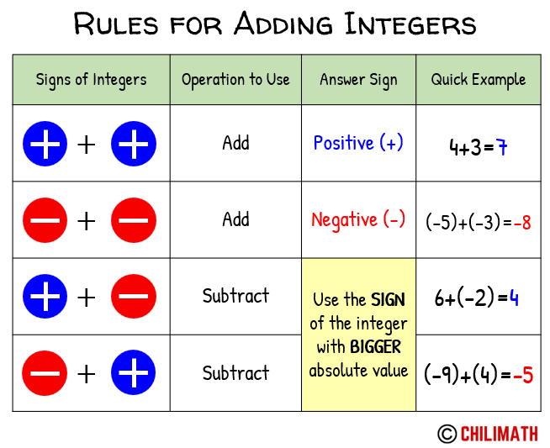 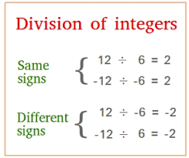

If you still need help watch the following video: https://www.youtube.com/watch?v=_BgblvF90UE

***Distributive property:*** https://www.youtube.com/watch?v=v-6MShC82ow

***Numbers set:*** https://www.youtube.com/watch?v=soNlNuT-Zrs

***numbers set song:*** https://www.youtube.com/watch?v=m94WTZP14SA

***Pythagorean Theorem:*** https://www.youtube.com/watch?v=WqhlG3Vakw8

***Basic inequalities:*** https://www.youtube.com/watch?v=mgHO-bsCDrA

***Solving and graphing inequalities:*** https://www.youtube.com/watch?v=EE2qWIyjKD0

***Linear functions:*** https://www.youtube.com/watch?v=MXV65i9g1Xg&t=610s